BUDO JUNIOR SCHOOL
REMEDIAL WORK FOR TERM 1 2020 - SET TWO
LITERACY II – PRIMARY ONE

Name : __________________________________________
Stream : ______________ Date:________________

SECTION A:
1. Fill in the missing letter.
sn__ke c___ke
t___ble f___sh

2. Write words correctly:
allb = ball
eetr = __________ sscla = __________
3. Name the sound pictures.
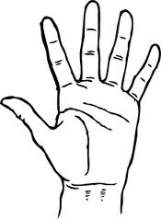 _____________
P
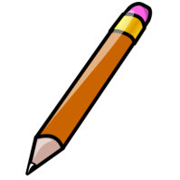 _____________

_____________
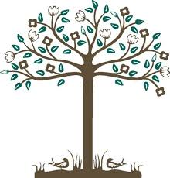
____________
t
_____________
_____________
4. Write these sentences correctly:
primary one I am in.
_____________________________________________
reading a book is Annet.
_____________________________________________

5. Form words using these sounds.
fl – flat oo - ____________
all - __________ gr - _____________

6. Read and draw.
a. A bird is on the tree. b. Musa is kicking a ball.

SECTION B:
7. Form a small word from a big word.
i) door = ________ teacher = ________
ii) pencil = _______ kitchen = ________

8. Complete the riddles.
a) I am made of wood.
I have four legs.
People sit on me.
What am I ?
You are a _____________________

b) I am black.
I stay in classrooms.
Teachers write on me with chalk.
What am I ?
You are a ___________________.

c) I am a domestic animal.
I have four legs and horns.
I give people milk and meat.
What am I ?
You are a _________________
9. Match correctly:
secretary classroom

house mother kitchen

teacher office

cooks sick bay

nurse dormitory

10. Use these words in the sentence.
(i) came : We came to school to learn.

(ii) have : _________________________________________

(iv) sitting :__________________________________________

11. Look at the picture and answer questions.
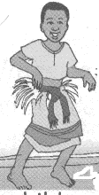
John Peter Rose
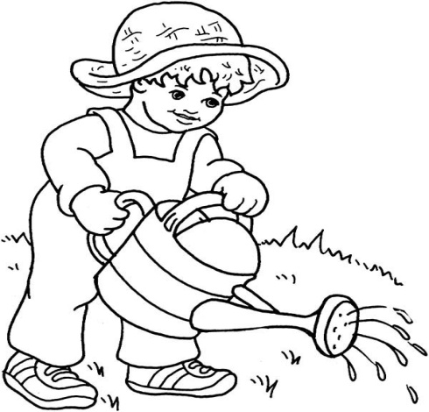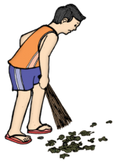

Simon Joy Mother
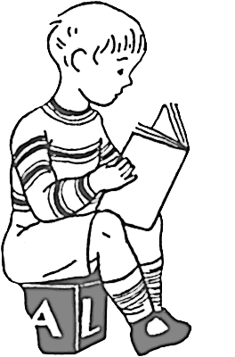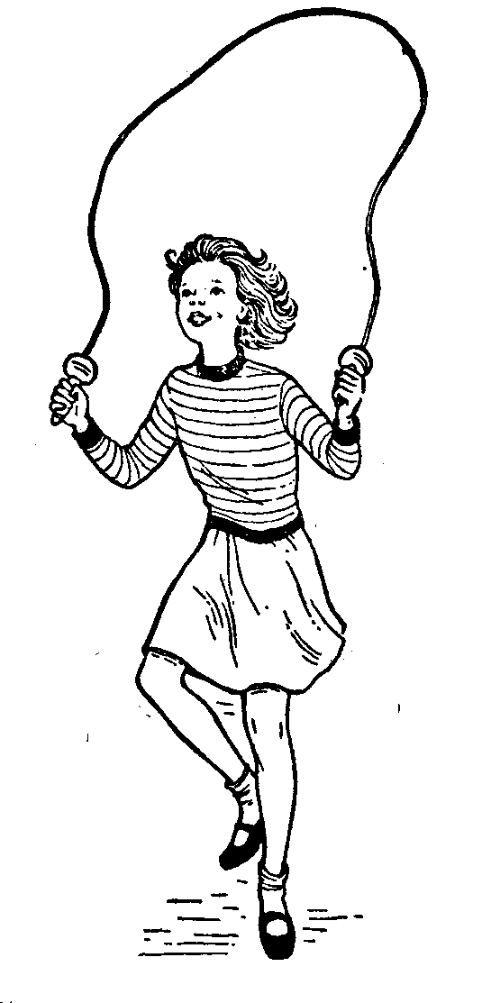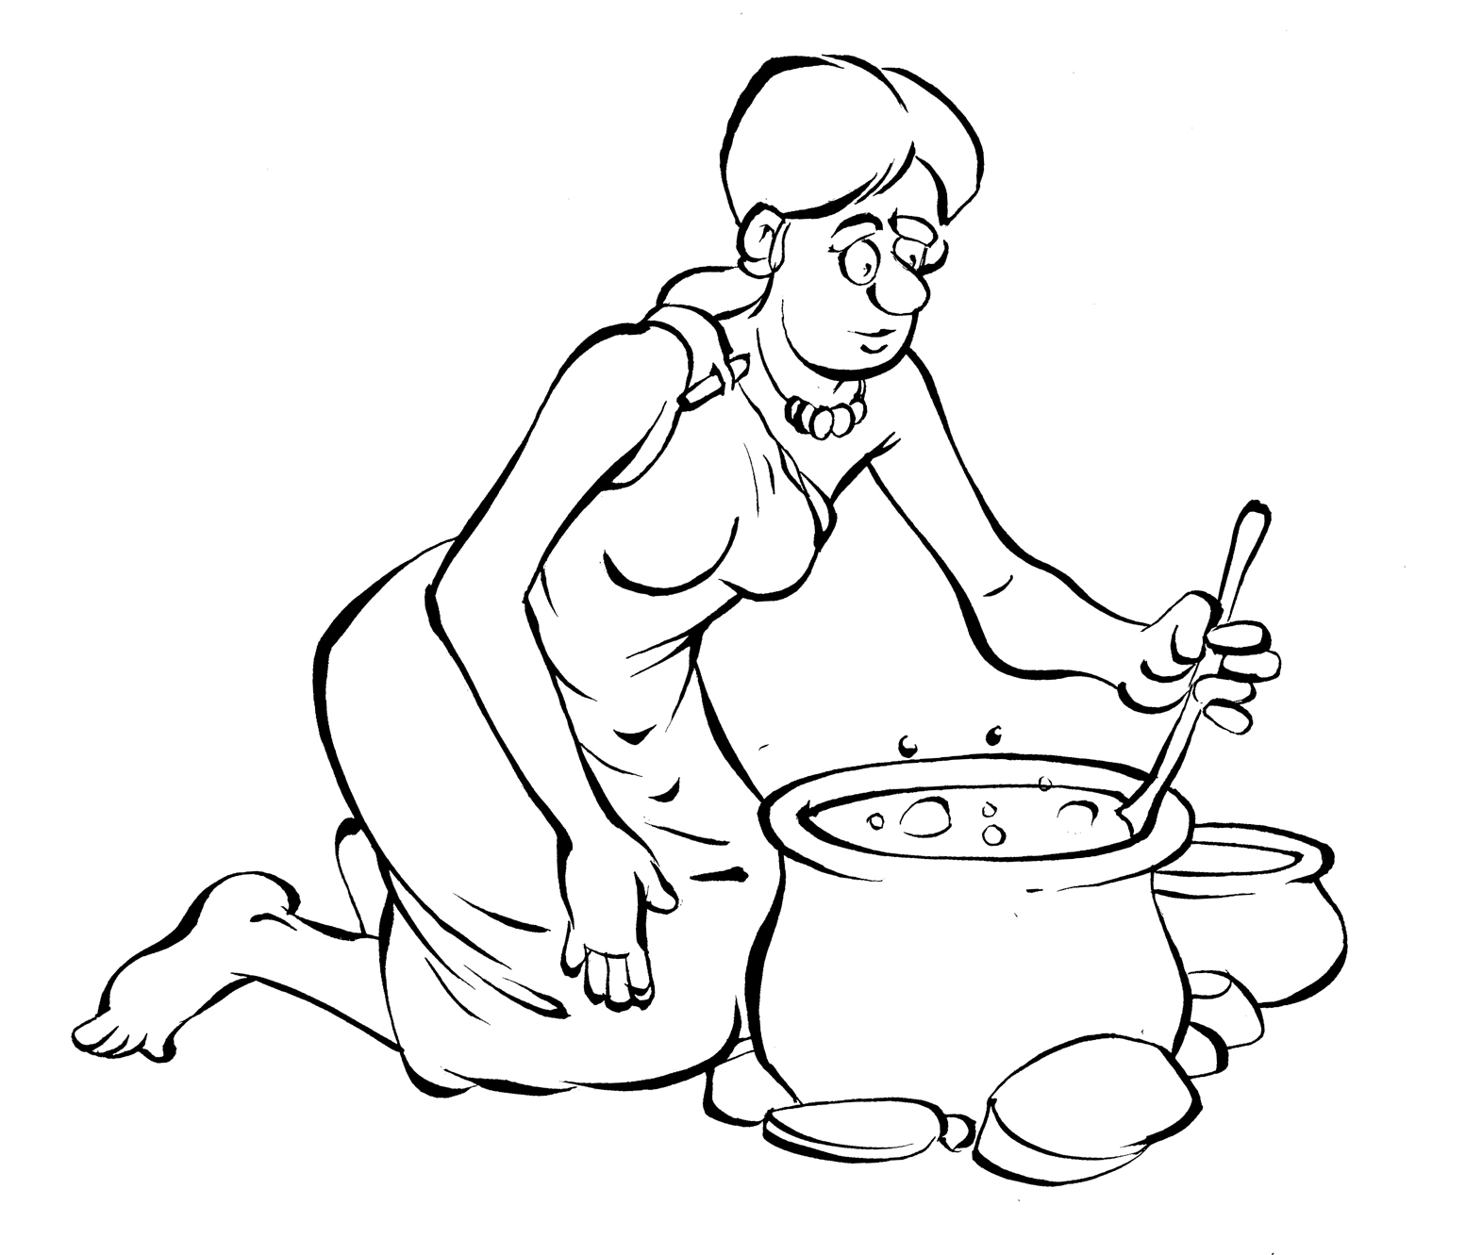

Questions
1. Who is watering plants?
_____________________________________________
2. How many girls are in the picture?
_____________________________________________
3. What is Simon doing?
_____________________________________________
4. Who is skipping?
_____________________________________________
5. What is Peter doing?
_____________________________________________
12. Read the dialogue and questions below:
A LESSON ABOUT INSECTS
Tina: Hello, Juli what did you learn about in your literacy lesson?
Juli: We learnt about insects.
Tina: Insects? What did your teacher say about insects?
Juli: Teacher said that insects have 6 legs and 3 main body parts.
Tina: 3 main body parts!
Juli: Yes please.
Tina: Tell me more about the 3 main body parts.
Juli: The main body parts are head, Thorax and Abdomen.
Tina: Thank you Juli. I have learnt that insects with more than
six legs are not insects.
Juli: It’s true.

Questions:
a) How many people are talking in the dialogue?
________________________________________________
b) Write their names.
________________________________________________
c) How many body parts has an insect?
________________________________________________
d) Which lesson is talked about in the dialogue?
________________________________________________

13. Complete these sentences.
a) As tall as a giant.
c) As thin as a ________________
d) As brave as a ______________
( thread , snow , lion , tree , bee )

14. Use the words below to complete the story.
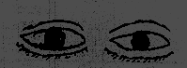
Our body parts are useful.
The ____________are used for seeing.

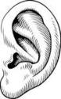 ________are for hearing.
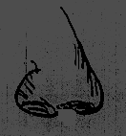
________ is used for smelling.
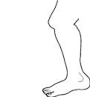 _________ are used for walking, the skin is used for feeling, _____________ are used for
touching, 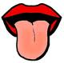 tongue is used for tasting
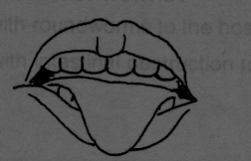
the ______________are used for chewing

and many others. We thank God for the body parts.
feeling , teeth , fingers , eyes , tongue ears , legs , nose

